**SOP FOR**

1. **PURPOSE: Safe dismantling and erection of blow pipe, tuyere & tuyere cooler**
2. **SCOPE:** **-** Blast Furnace & Accessories.
3. **RESPONSIBILITY: Engineer In charge and workmen on job.**
4. **PROCEDURE: DISMANTLING AND ERECTION OF BLOWPIPE & ACCESSORIES, TUYERE*,* TUYERE COOLER.**

**LIST OF TASKS COVERED:**

Activity 1: **Dismantling & Erection of Blow Pipe with Elbow (Danielli corus design**

**Activity 2: Dismantling & Erection of Tuyere & Tuyere cooler.**

Activity 3: **Dismantling & Erection of Large water jackets.**

**PPE –s to be used:**

* Helmet, Safety shoes safety goggles, **Apron** and Hand gloves. Face shield

**Aspect – impact**

|  |  |
| --- | --- |
| Scrap generation  Asbestos | Resource Depletion  Hazardous waste |

**Hazards identified**

**Physical Hazard**: Pressure, temperature, sudden exposure to flame and hot coke due to furnace slip.

**Mechanical Hazard**

* Trapping between two objects, fall of material, hammer, tools, linged items, bolts, and blowpipe, wedges.
* Fall of person from platform,
* Entanglement,
* Impact of moving / slinged items.
* Back Pain due to sudden or heavy load like blow pipe elbow.
* Non use of PPE’s while carrying out the activity

**Chemical:** CO gas poisoning.

**Behavioral Hazards:**

1. working without all required PPE’s
2. Working under influence of alcohol
3. Horse play
4. Casual approach
5. Not following SOP/WI while carrying out the job

**Activity 1: Dismantling & Erection of Blow Pipe with Elbow (Danielli corus design)**

1. Take work permit from production department.
2. Follow WI/BF3/02 for peephole flange opening & closing.
3. Backdraft valve in open condition...
4. Bleeder valve in open condition.
5. Check that Tuyere are plugged and wind is OFF.
6. All workmen engaged in this activity should be wearing an Apron.
7. Ensure that all-necessary tools and tackles are ready. Use tested chain block/D shackles/slings of minimum capacity of 3 T.
8. Fix a chain pulley block on the mounting bracket of furnace shell (above the blowpipe & opposite of compensator) and other end to be fixed on elbow hook & take load.
9. Another chain block should be used at the rear end of the elbow & mounted on the circular mono rail trolley.
10. Note: Please ensure to check the condition of monorail trolley before use, check whether wheels are properly mounted on the beam track , check for stud condition etc.
11. Loosen the Spring-type sideways bridle unit of the air blast unit assembly using torque wrench.
12. Hold the neck of elbow using D shackle & take load on monorail trolley chain pulley block.
13. Now open the bolts & nuts of elbow flange using torque wrench.
14. Lower both chain pulley blocks gradually
15. Further loosen the Elbow & blowpipe. Take out the assembly from Tuyere cooling chamber.
16. Take out the assembly with the help of chain pulley block mounted on the circular monorail trolley.
17. Replace the SS gasket & Glass wool of elbow to distance piece joint with new one.

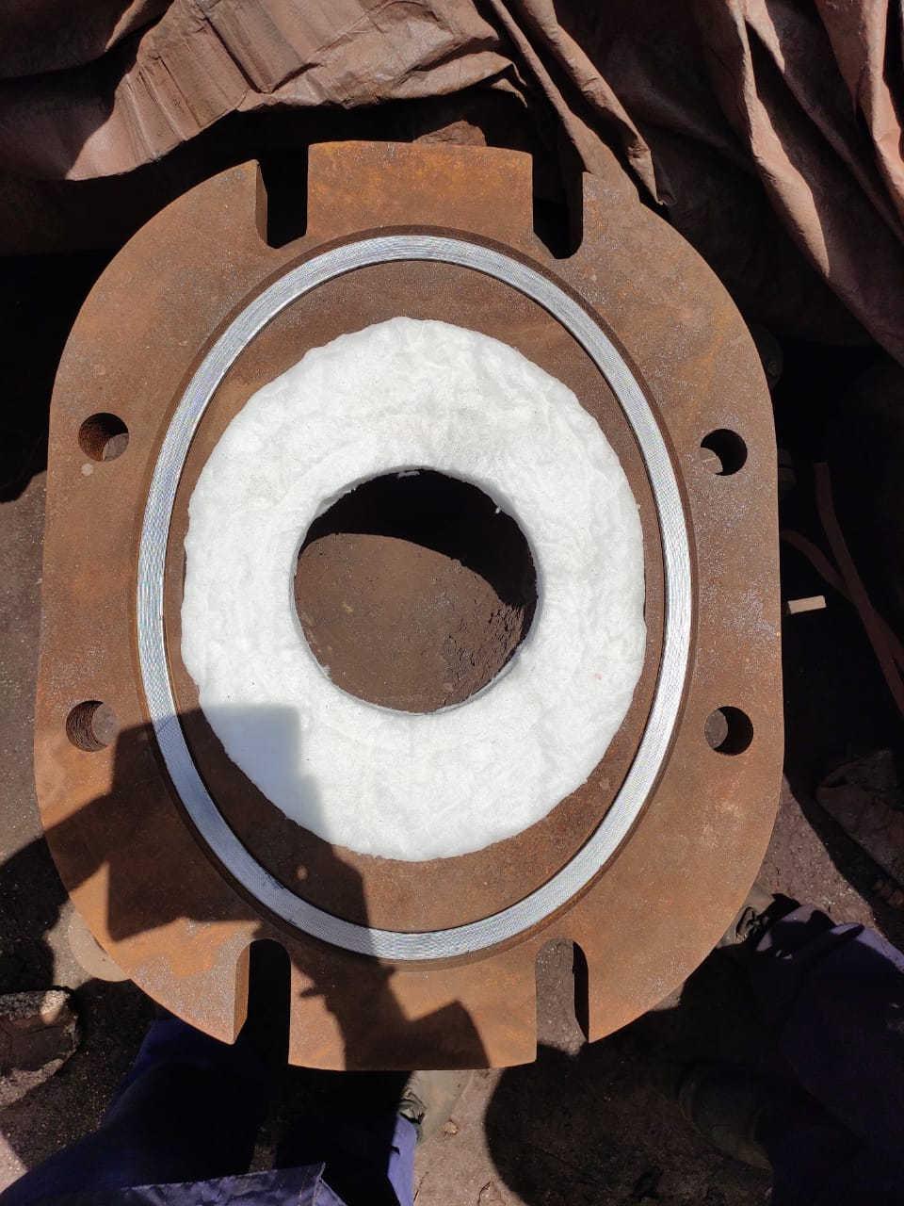

Border for glass wool

Glass wool

SS gasket

1. Ensure that glass wool should not cross its seating which is marked in red, if it crosses its seating after fixing then chances of blast leakage through both mating flanges.
2. Clean the front nozzle contact surface before assembling the blowpipe.
3. Once the straight pipe & elbow is in place, check for the straightness by viewing from peephole flange using a torch. Check the equal gap between elbow & distance piece flange.
4. Fitting & tighten flange bolts
5. Tighten the spring type side bridle unit up to the specified marking (20mm).
6. Check for gap at blowpipe and Tuyere seating area using 0.1mm filler guage.
7. If there is no gap noticed then chain block can be removed else fine setting needs to be carried out.
8. Clearance can be given to production after clearing the work permit.

**Activity 2: Dismantling & Erection of Tuyere & Tuyere cooler**

1. Take work permit from production department and check that tuyeres are plugged and wind is OFF.
2. Follow Activity 1 for dismantling of blow pipe. Once blow pipe is removed, Operation dept. shall replace the tuyere with spare tuyere that is kept ready.
3. Ensure that tuyere is plugged before other checks of tuyere are carried out.

**Note**: Ensure that SS pipes of spare tuyere /tuyere cooler are firmly tightened and male connector of quick release coupling is connected to the SS pipe.

1. Maintain tuyere to tuyere cooler distance to 285-290 mm all around. Check the gap with 0.05mm feeler gauge if required.
2. Re fix the blow pipe as per Activity 1

Note: Tuyere cooler can be replaced in similar manner once tuyere is removed.

Activity 3: **Dismantling & Erection of Large water jackets.**

1. Take work permit from production department and wind is OFF.
2. Follow Activity Dismantling of blow pipe as per the work instructions. Once blow pipe is removed, Operation dept. shall remove the tuyere & middle water jacket.
3. Once get the clearance from operation, then start removing the large water jacket by removing the mounting bolts.
4. Insert the wedges between clamping & large water jacket flanges by hammering to create the gap and pull out with puller & jack to remove the jacket.
5. If it is not coming out then cut with the help of oxygen lancing by operation department.
6. Position the new jacket by 2nos 2tn chain blocks with the help of special lifting arrangement.

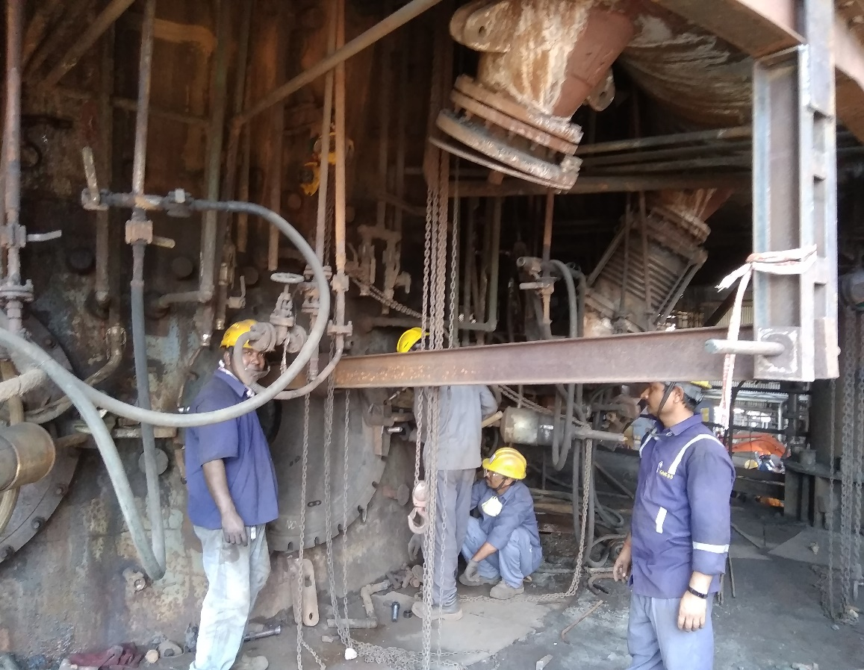

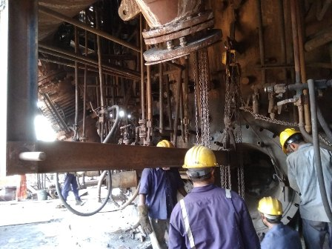

1. Insert the mounting bolts & sealing rope between both flanges.
2. Tighten the bolts & connect the water cooling lines.
3. Give clearance to operation to fix back the middle water jacket & Tuyere, ensure that water cooling line to be connected for the same.
4. Maintain tuyere to tuyere cooler distance to 285-290 mm all around. Check the gap with 0.05mm feeler gauge if required.
5. Mount back the blow pipe assembly.
6. Clear the work permit & check the leakages once wind is ON.

**DO**:

* Check the condition of chain block and its certification label before taking in use.
* Check the chain block holding hook for any corrosion or wear out.
* Ensure to check that the tuyere is plugged before you proceed for dismantling.
* Wear Apron for this activity

**DO NOT:**

* Stand below the hanging material while lifting the blowpipe.
* Gas cut the spring loaded hold down unit.
* Stand directly in front of the tuyere during replacement.
* Over crowd in blow pipe area ( risk related to furnace slipping)

**REFERENCES: Operation & Maintenance manual.**

**Amendement Record**

|  |  |  |  |
| --- | --- | --- | --- |
| **Date** | **Manual Section Ref. & Para** | **Brief details of Revision** | **New Rev.** |
|  |  |  |  |
|  |  |  |  |
|  |  |  |  |

|  |  |  |
| --- | --- | --- |
| **Prepared By:**  Digital head VAB | **Reviewed & Issued By:**  Management Representative | **Approved By:**  Mechanical and Asset Integrity Head VAB |
| **Signature:** | **Signature:** | **Signature:** |
| **Review Date: 07.06.2023** | **Review Date: 07.06.2023** | **Review Date: 07.06.2023** |